Preparing for Work Experience (WEX)
and post-16 options



Name…….....................

Form……………

Please do not take this booklet out of form!

Introduction
What is this booklet for?
Once a week during form time, your tutor will share information to help you prepare for your work experience placement. Although this may seem some way off, preparation is key to ensuring a positive experience. Leaving your arrangements until the last minute may limit your choices and prevent you from securing your preferred placement.
What is work experience?
It is an opportunity to carry out real work tasks on employers’ premises and experience the hours, working conditions and disciplines you will encounter as employees. Depending on your placement, it can also provide an opportunity to find out more about a career path that you may be interested in
Why is work experience important?
Work experience gives you a valuable insight into the world of work and the chance to meet new people. It helps you:
Make decisions: Try out a working environment and explore potential career paths.
Build confidence: Work as part of a team and take on real tasks.
See the value of learning: Understand how school skills link to real jobs.
Develop skills: Discover your strengths and improve your employability.
Network: Meet professionals and learn about different roles, skills, and qualifications.
What are the expectations?
You should keep this booklet in your form room and complete each activity as you go. These tasks are designed to support you in finding and securing your own placement, contacting employers, and reflecting on the skills you already have as well as those you would like to develop. You are expected to take responsibility for arranging your own work experience placement, using the guidance provided in this booklet. By the end of Year 10, this booklet will become a valuable resource to guide you as you begin making your post-16 choices at the start of Year 11.
Who can I talk to if I need support?
Thinking about your future can bring up a range of emotions. Some students may feel excited about their work experience, while others may feel a little nervous. These activities are designed to help you feel as prepared and confident as possible, and support is always available if you need it. If you would like some extra help along the way you could talk to your form tutor, Mrs Warwick (Careers Advisor) or Miss Andrews or a trusted adult outside of school.

Key dates

Session One: How do you get a work experience placement?
Your work placement may be your first real experience of the workplace, so it’s normal to feel a little nervous. Preparation is the best way to build confidence and get the most out of the experience.
Don’t worry if you’re unsure about your future career—work experience is a great way to explore your options. Start by thinking about your interests and strengths to help guide your choices.
Ask yourself the following questions and record the answers below:

What are my favourite subjects at school?

What subjects am I good at and which ones do I find more difficult?

What do I enjoy doing outside school or college?

Could I turn my hobby into a career?

What jobs have I heard about or seen other people doing?

Could I see myself doing any of these jobs?

Session Two: My WEX Targets
Here you should list three to five targets you would like to gain from your work experience placement:

Top tip: It’s a good idea to share these targets with your employer when you arrive. They might suggest some additional targets, add these in below:

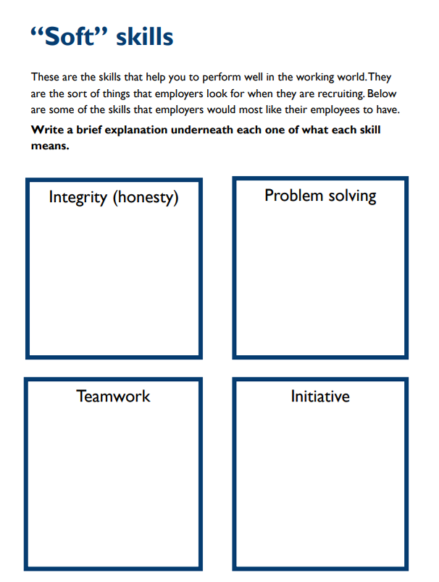
Session Three: Skills
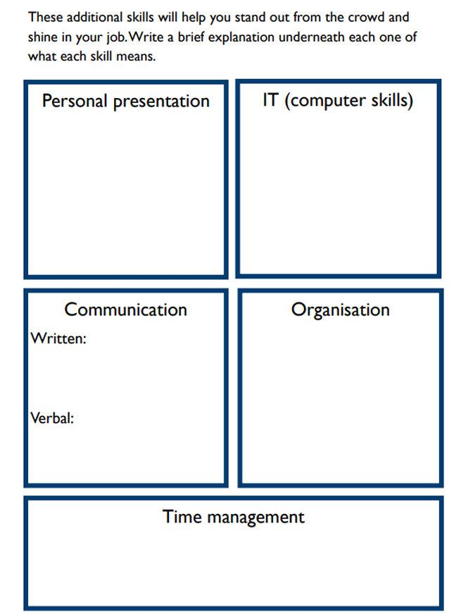
You already have many of these skills through school, home, or your free time. Use the table below to give examples of when you have shown these skills.
Skill | I have demonstrated this by… | Example of how this could be demonstrated in the workplace…
Communication (Written) | My creative writing in English lessons. | Writing an email to send to a customer.
Communication (Verbal)
Integrity
Problem Solving

Teamwork
Initiative

IT Skills

Organisation

Time management

Session Four: Character Strengths
Your work experience is a great chance to show your CORD strengths—compassion, opportunity, resilience, and discovery. You’ll build confidence, work with others, solve new problems, and develop a strong work ethic while gaining valuable real-world experience.
Character Strength | How can I demonstrate this skill in the work placement?
Compassion
Opportunity
Resilience
Discovery

Session Five: Researching possible placements
Once you know what industry you would like your work experience to be in, speak to family and friends about companies that might have placement opportunities.
Every employer offering work experience must have Employers Liability Insurance or the placement will not be approved. Please check this with the company.
Make a note of any interesting companies and contact details using the table below.
NOTE- All schools in the area are expected to complete work experience and companies will have a limited capacity, the sooner you get in contact the better!
Name of company | Contact information | Reply (Yes/No)

Session Six: Contacting Potential Placements
WORK EXPERIENCE EMAIL TEMPLATE
Dear Sir/Madam [or name],
I am a [X year old] [year group] student from Taverham High School studying [list of subjects].
I am enquiring about a potential work experience placement at [company name], from [start date] to [end date].
I’m keen on gaining some practical work experience in [chosen field of work], because [reasoning for pursuing a placement with this specific company and field]. I am [list some of your personal skills and qualities e.g. friendly, reliable, hard-working, enjoy meeting people etc.]
My personal interests are [write any down that may help with your application]
As an enthusiastic student with a keen interest in what your organisation does, as well as a passion to progress within this industry, I would be very grateful to be considered for an opportunity at [company name].
I look forward to hearing from you soon.
Yours [sincerely if writing to a named person/faithfully if you started with Sir or Madam]
[Your name]

WORK EXPERIENCE TELEPHONE TEMPLATE
Hello, my name is [X] and I am a Year 10 student from Taverham High School.
I’m ringing up regarding a possible work experience placement on [dates]. Would it be possible to speak to the person responsible for this?
Thank the person for their time (even if they cannot offer you a placement)
Tips and Advice:
• If you are told they are out / busy, ask politely for their name and contact number so that you can ring back another time, and write these details down.
• You probably will not get an answer straightaway so be ready to give your contact details.
• Ask how you should go about arranging the placement. Explain that there is some paperwork that must be completed. Ask if you can bring this in / send it in.
• If you do not get a reply within 5 working days, phone up the company and ask again.

WORK EXPERIENCE LETTER TEMPLATE
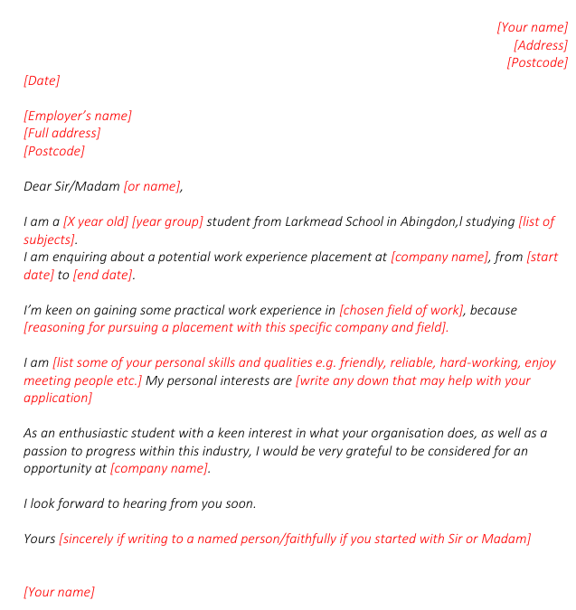

You may need to attach a CV to your letter; we will cover this in a later session.
Some companies will have an online application form; you may be able to use these templates to help you.

Session Seven: Health and Safety
Sign names:  A) Danger: Obstacles  B) Emergency exit  C) No smoking  D) Fire extinguisher  E) First aid  F) No naked flames  G) Safety boots must be worn  H) Safety helmet must be worn  I) Eye protection must be worn  J) No access for pedestrians  K) Danger: Flammable material  L) Danger: Electricity | Match the health and safety sign name to the graphic:
 |  |  | 
 |  |  | 
 |  |  | 
 |  |  | 
Who should you talk to if you see a health and safety risk while on work experience?

Remember: You will be informed of any health and safety rules you must adhere to at work.
You must inform your employer of any medical conditions or health issues you may have, especially if they could affect your ability to undertake certain tasks.

Session Eight: How to behave in the workplace
Use this page to add notes from the information provided by your form tutor

Write down below three key takeaways from today’s session:

Session Nine: Social Media and Online Presence
Good social media account
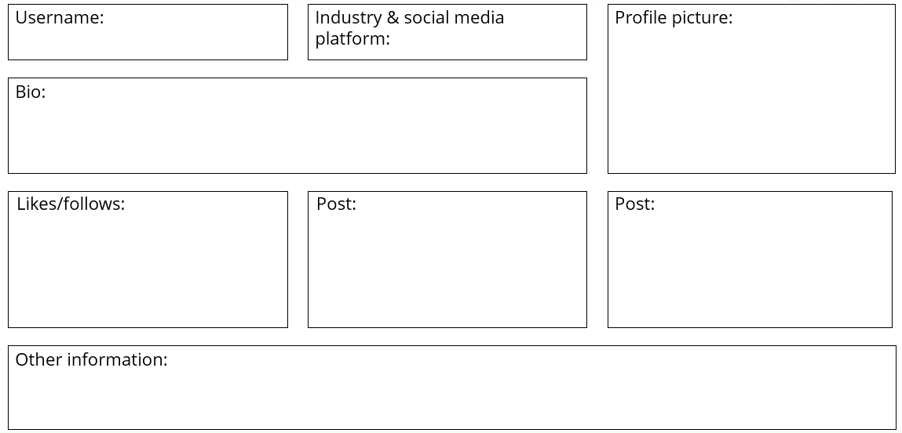
Bad social media account

Session Ten: Building a Brand
1. What percentage of job recruiters have rejected candidates based on information that they found online?
a. 25%
b. 55%
c. 70%
2. Which of the following is NOT a good way to stay safe online?
a. Make yourself difficult to find on Facebook by only using your first name (e.g. Matt Hew or Em Ma).
b. When meeting with someone from a dating app for the first time, invite them to your house so you’re sure of the date location.
c. Limit the amount of personal information you share online such as date of birth or contact details.
3. If someone bullies or harasses you online you should…
a. Block them.
b. Block them and report them using the site’s report function.
c. Block them, report them using the site’s report function, and tell someone about it.
4. Which one of the following statements is TRUE?
a. Job recruiters will reject your application if they find out you use social media.
b. Job recruiters don’t check your social media – it would take too long.
c. Job recruiters don’t mind if you have an online presence (some might prefer it if you do!) They mainly want to know that will be a good representative of their organisation.
Finish the following sentences:
My online presence is important because…
My online presence is important but…
My online presence is important so…
Session Eleven: CV and Cover Letters
Why do you think a CV is important? Write down three reasons below:

Compare the following cover letters
Cover letter one:
To Whom it May Concern,
I am writing to apply for the engineering apprenticeship with GSK, as advertised on RateMyApprenticeship. Please find my CV enclosed. I would really, really, really love the opportunity to work for such an amazing and outstanding company as GSK.
I am particulaly interested in the enginering apprenticeship because of my lifelong interest in engineering. I have always taken an active interest in how things work; wanting to get to the root of mechanical problems and devise accurate and efficient solutions. I am 100% sure that this apprenticeship would allow me to further develop this passion, and learn from industry professionals, such as those that work at your company.
As my CV describes, I have loads of work experience relevant to the positions. I have worked for three years at Carlos’ Cakes, meaning I have good team work skills. I have taken part in the NCS sumer programme in August 2017 meaning I have developed my leadership skills. Also, I worked at NTAR during work experience in May 2017,, meaning I have a good knowledge of the industry. Furthermore, I have volunteered at a play centre for young children from 2015-2017, showing that I am a committed individual who can be relied on Thank you for reading my cover letter; I hope that I am the right person for the job. Yours Sincerely, Name.
Cover letter two:
Dear Barbara Smith, I am writing to apply for the engineering apprenticeship with GSK, as advertised on RateMyApprenticeship. Please find my CV enclosed.
I am particularly interested in the engineering apprenticeship offered by GSK because of its focus on chemical engineering. GSK’s devotion to the research of existing and new medicines aligns with my own desire to contribute to the creation of new medical practices. GSK are focusing on local COPD care, and I feel that my hospital work experience makes me an ideal candidate for this apprenticeship.
As my CV describes, three years working at Carlos’ Cakes have given me team-working skills, and the ability to work independently. I am a conscientious and committed student, on course to achieve three A-levels. My particular focus on Biology has provided knowledge that will be needed for this apprenticeship. I am confident using Microsoft Office and have the desired experience with Photoshop software.
Thank you for considering my application, I would enjoy the opportunity to interview, so that we can discuss the apprenticeship programme in greater detail.
Yours Sincerely, Name.

What one cover letter better? Some things are obvious, and some are much more subtle. Use the comments function to annotate the cover letters to show your thinking.

Think about how you can improve the cover letter you thought was worse. Pick three things you could improve and annotate the cover letter to show them.

Independent Learning Task ( Optional)
Now you’re an expert in CVs and cover letters, it’s time to practise creating your own!
The Unifrog CV/Resume tool can help you create and format your CV. All you have to do is input your work experience, competencies, and anything else you want to highlight to an employer.
Log into your Unifrog account and scroll down to the ‘Drafting application material’ section. Here you’ll be able to click into the ‘CV/Resume’ tool.

Session Twelve: Interview Preparation
What is the purpose of an interview?

What happens in an interview?

How could you prepare for an interview?

How should you present yourself in an interview?

Write down two top tips below and share them with a partner:

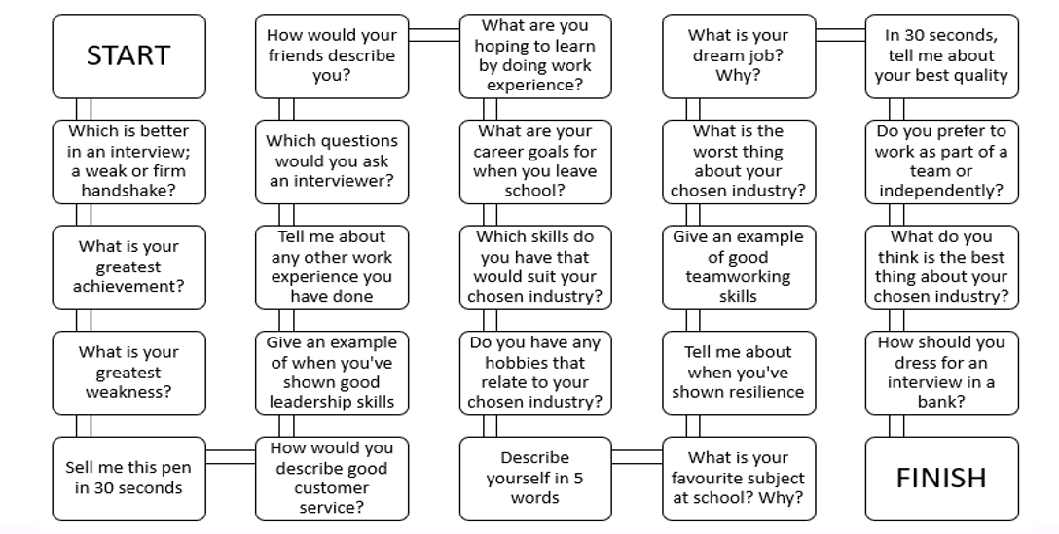

Session Thirteen: Checking-in session
This is an opportunity for you to reflect on what preparations you have done for work experience and what still need to be completed.

Session Fourteen: Problem Solving
Task- Outline the five steps to problem solving below
- Identify

- Research and analyse

- Create and develop solutions

- Choose the best option

- Evaluate

Where does Ralph show these skills in the following scenario? Highlight them below:
During his work experience at a garage, Ralph demonstrated strong problem-solving skills when helping with a car that wouldn’t start consistently. He identified that the issue was intermittent, then analysed patterns by noticing it happened more often when the engine was cold and the lights flickered. Ralph suggested several possible solutions, such as checking the battery and connections, and decided to start with the simplest option. After cleaning the battery terminals and testing them, the car began working reliably. Ralph then evaluated the outcome, recognising that starting with basic checks was effective and that he would follow this approach again in the future.
Session Fifteen: Speaking and Communication
HOW WELL CAN I COMMUNICATE WITH OTHERS?
Rate yourself from 1–10 on the following:
- Active listening
- Rephrasing and summarising
- Understanding tone
- Recognising influence
- Comparing viewpoints
- Clear expression
- Using facts and examples
- Engaging audience
- Adapting communication
- Presenting to an audience

Reflection: Which aspects need the most work? What could you do to improve?

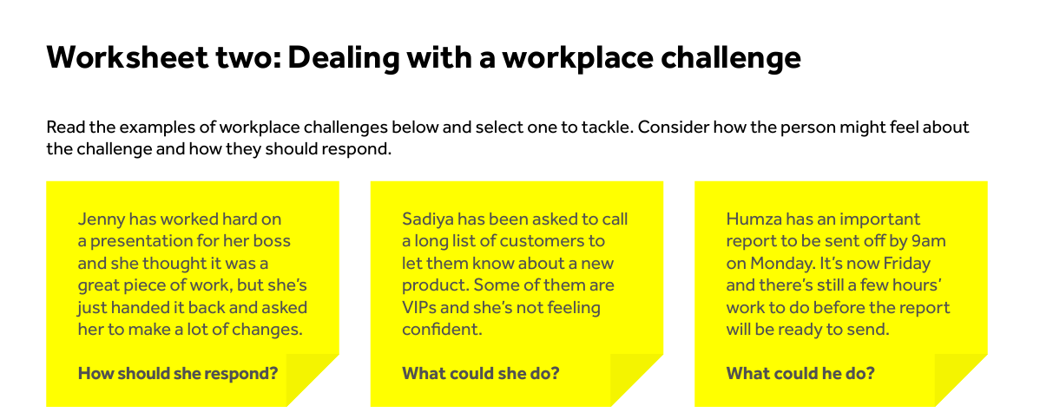
Session Sixteen: Self- Confidence and Taking on Challenges

What might their fears be when thinking about the challenge or problem?

How could they turn the challenge into an opportunity?

What skills might they need to successfully tackle the challenge?

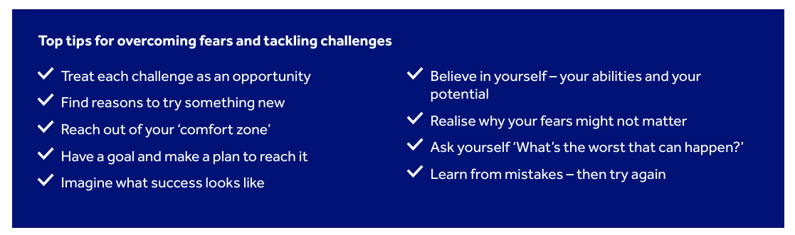
Session Seventeen: Proactivity
Why is it important to think ahead and consider the different things we might need when setting goals?

How can we set tangible goals in our stretch zone?

Can you give examples of when you’ve done this?

Why is it important to be willing to take on new challenges?

When do we need to involve other people to achieve our plans

How might you demonstrate proactivity on your WEX placement?

Session Eighteen: Resilience
What challenges might you face during WEX week?
Example- Your bus does not arrive in the morning.

How could you overcome these challenges?

Is there anyone who could support you?

Session Nineteen: Employment Sectors
Pick Three Sectors you would like to work in and why

Pick Three Sectors you would NOT like to work in and why

Which sector does your WEX placement come under?

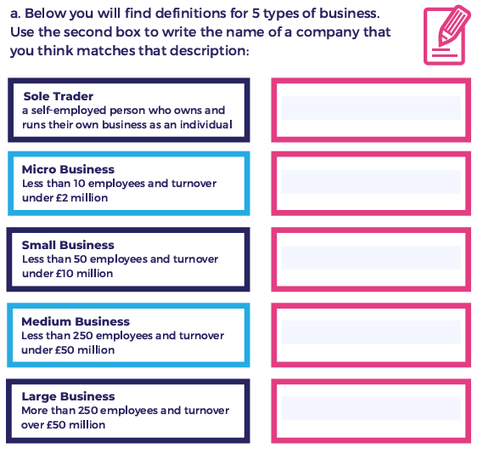
Session Twenty: Different types of businesses

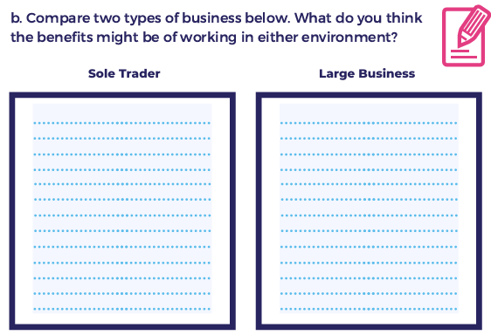

Which type of business is your WEX placement?

Session Twenty-One: How the world of work has changed
Think of a business that had changed the way it works and answer the following questions.
- What big changes have they made?

- How have the changes improved the business?

- What impact might this have on staff?

How do you think the world of work could change in the next 10 years?
- What type of jobs might be created?

- Which jobs might no longer be needed?

- What big, new challenges may businesses face?

Session Twenty-Two: Business Functions
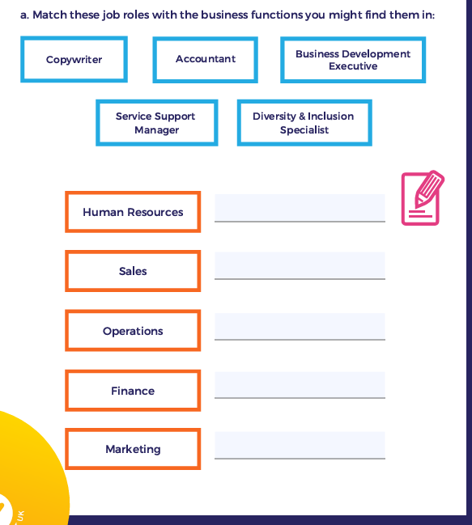

What business functions are there at your WEX placement? Which functions would you like to experience?

Session Twenty-Three: Different Career Roles
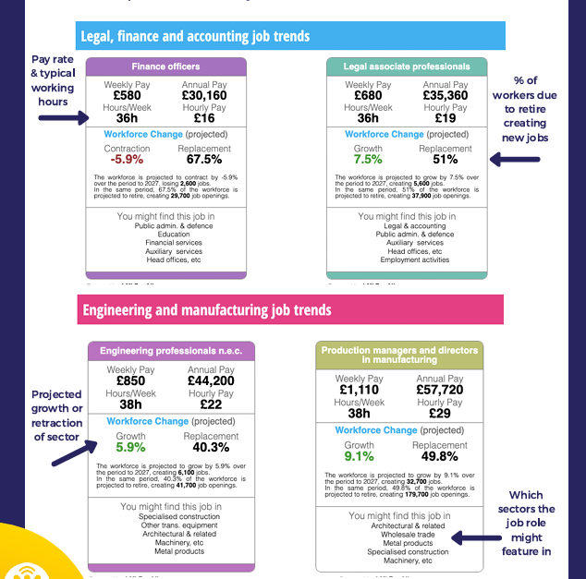
Quick check questions
- Which career role is expected to see the biggest need of candidates because of retirement?

- Which career role has the better hourly rate of pay?

- Which career role has the highest percentage of growth rate?

Session Twenty-Four: Routes into Work

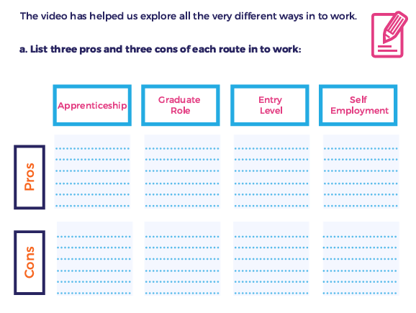
Which route in to work do you think you are best suited to?

What is the best route in to work for your WEX placement?

Session Twenty-Five: Post-16 options
Make notes here:

Session Twenty-Six: Are A-levels right for me?
Make notes here:

Session Twenty-Seven: Are BTEC’s right for me?
Make notes here:

Session Twenty-Eight: Is an Apprenticeship right for me?
Make notes here:

Session Twenty-Nine- Is a T-Level right for me?
Make notes here:

Session Thirty- Are V-levels right for me?
V levels are a new level 3 qualification in England, due to start in September 2027. The ‘V’ stands for ‘vocational’, and they’ll exist alongside T levels (technical levels) and A levels (advanced levels) to give students a wider range of study options. You can study them alongside English and maths GCSE resits depending on the entry criteria for your chosen subjects.
 | A levels | V levels | T levels
Type of pathway | Academic | Vocational | Technical
Learning style | Academic, single subject study. | Hands-on study to build sector knowledge and skills. | In-depth technical study of one career-focused area. Includes an industry placement.
Assessment types | Usually involves coursework, exams, or a mixture of both. | Will likely be a mixture of skills-based assessments, practical tasks, performances (where relevant), and written tasks. | Combines written assessments, skills assessments, observations, completion of a work placement, and completion of an employer-set project.
Grade scale | A*–E, U | Undecided (as of July 2026) | Distinction*–Pass
How they work alongside other qualifications | Typically studied as a combination of three A level subjects. | Make up the equivalent of one A level and can be studied alongside them. | Equivalent to three A levels and cannot be studied alongside another programme.
As with most new qualifications, you’ll have a small number of subject choices to start with, with the aim to broaden the subject choices by September 2030.
In September 2027, you’ll be able to study:
- Digital
- Education and early years
- Finance and accounting
By September 2028, you’ll be able to study:
- Business and administration
- Care services
- Construction and the built environment
- Engineering and manufacturing
- Health and science
- Legal
- Sales, marketing, and procurement
- Sports, fitness, and exercise science
Additional Notes Page 1

Additional Notes Page 2

